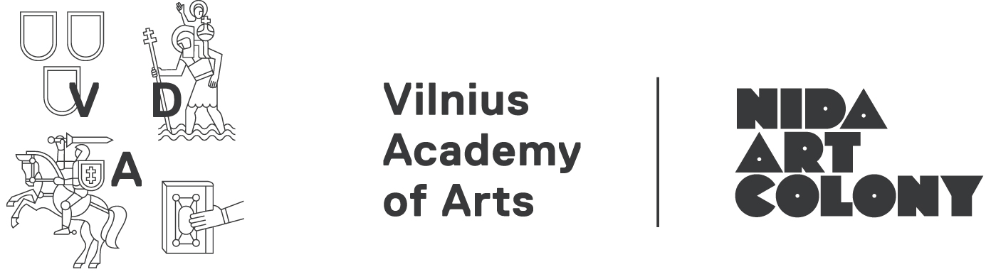
Application for artist-in-residence programme 2017/18
Type of residency: | □ Individual residency (August 2017 – July 2018, applicants from all over the world; no grants available, selected artists are issued a letter of support for individual grant seeking)  □ Doctoral residency (July – September 2017, doctoral students from all over the world; no grants available, selected artists & researchers are issued a letter of support for individual grant seeking)  □ The 7th Inter-format Symposium Along Lines (May 19-22, 2017, no need to fill in this application form, the link to portfolio and CV is enough with a few sentences why you would like to attend the event or how your practice relates to its topic)
Family name:
First name:
Nationality:
Date of birth:
Address: | Street:  City:  Country:  ZIP code:
Telephone number:
Email address:
Website:
Affiliated organization (if any):
How did you find out about this programme? (if online please specify which website, newsletter or mailing list)
Field of arts | Visual Art □ Design □ Architecture □ Artistic Research □  Research related to Art □ Curator □  Other:
Preferred residency period | 1-4 month-long individual or 1-2 month doctoral (July-September 2017 only) residencies (we recommend at least 2 month-long residencies; applicants from all over the world), 400 eur/month*:  2017 July □ August □ September □ October □ November □ December □  2018 January □ February □ March □ April □ May □ June □ July □  *For Lithuanian residents a price of 300 Eur/month is applied for the residency period from October to May, summer months are subject to the general price
Language proficiency | English:  Fluent □ Advanced □ Intermediate □ Beginner □
Artist/Research statement
(if you come for a residency it might be published on our web site, max. 200 words)
Activity / project proposal while in residency
(max. 200 words)
Educational opportunity | I would like to give a workshop at local high school or art school if my residency is between September-December 2017 in exchange of the ~200 EUR fee  Yes □ No □
Attachments | □ CV □ Portfolio (Application documents and portfolio should be combined into one pdf/word file)

More information about our facilities www.nidacolony.lt
All applications are to be sent by email to info@nidacolony.lt with indication of the residency type
Please do not send files bigger than 10 MB. If you have larger files please zip them or send by online file sharing service (for ex. www.wetransfer.com).
Deadlines 15th March 2017
If you have any queries please contact residency curator Skaistė at skaiste@nidacolony.lt
or artistic director Vytautas at vytautas@nidacolony.lt

