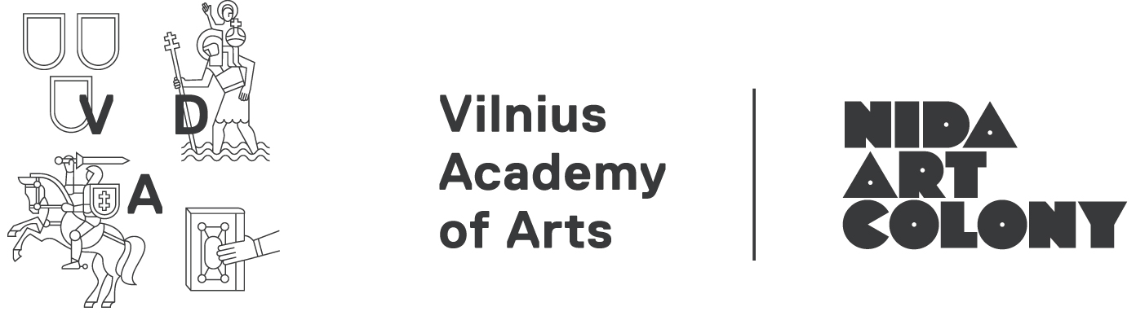
Application for artist-in-residence programme 2018/19
Type of residency: | □ Individual residency (September 2018 – May 2019, applicants from all over the world; no grants available, selected artists are issued a letter of support for individual grant seeking)  □ Doctoral residency (August – September 2018, doctoral students from all over the world; no grants available, selected artists & researchers are issued a letter of support for individual grant seeking)  □ 1-year-long-residency for Nordic-Baltic artists (September 2018-August 2019)  □ Production residency for the 8th Inter-format Symposium  * Participants of the 8th Inter-format Symposium On Rites & Terrabytes (June 20-24, 2018) don’t have to fill in this application form. In your proposal (up to 388 words plain text and 3 images) please indicate the preferred format, location and length of your contribution. If necessary, link URL to your CV and portfolio or/and attach 1 PDF file.
Family name:
First name:
Nationality:
Date of birth:
Address: | Street:  City:  Country:  ZIP code:
Telephone number:
Email address:
Website:
Affiliated organization (if any):
How did you find out about this programme? (if online please specify which website, newsletter or mailing list)
Field of arts | Visual Art □ Design □ Architecture □ Artistic Research □  Research related to Art □ Curator □  Other:
Preferred residency period | 1-4 month-long individual residency (we recommend at least 2 months), 400 eur/month*:  2018 October □ November □ December □  2019 January □ February □ March □ April □ May □  Preferred length of the residency: 1□ 2□ 3□ 4□ months  -------------------------------------------  1-2 month-long doctoral residency, 400 EUR/month*  2018 August □ September □  *For Lithuanian residents a price of 300 EUR/month is applied for the residency period from October to May, summer months are subject to the general price  -------------------------------------------  1-2 month symposium production residency for the 8th Inter-format Symposium. Grants are offered to selected residents.  2018 May □ June □  -------------------------------------------  1-year-long-residency for one Nordic-Baltic artist  (September 2018-August 2019) □
Language proficiency | English:  Fluent □ Advanced □ Intermediate □ Beginner □
Artist/Research statement
(if you come for a residency it might be published on our web site, max. 200 words)
Activity / project proposal while in residency
(max. 200 words)
Attachments | □ CV □ Portfolio (Application documents and portfolio should be combined into one pdf file)

More information about our facilities www.nidacolony.lt
All applications are to be sent by email to info@nidacolony.lt with indication of the residency type
Please do not send files bigger than 10 MB. If you have larger files please zip them or send by online file sharing service (for ex. www.wetransfer.com).
Deadlines 15th March 2018
If you have any queries please contact Residency Curator Skaistė at skaiste@nidacolony.lt
or Artistic Director Vytautas at vytautas@nidacolony.lt

